Go back to The KISS Homepage
Additional Materialsfor  KISS Grammar | 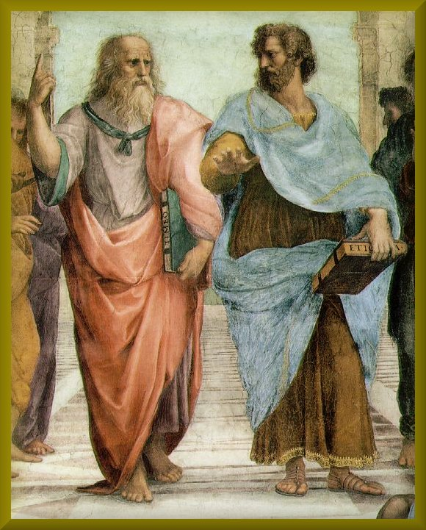 | Detail of  Plato and Aristotle  from the  School of Athens  1511, Fresco  by Raphael  (1483-1520)  Stanza della Signatura  Vatican Palace, Rome
On the left, Plato, who believed that philosophers could know the absolute truth, points upward to the world of forms. Aristotle, on the right, wasn't so sure of that. He points outward, representing a "middle way"--man should avoid extremes. This difference between the two is fundamental to an understanding of most of the disagreements between human beings.

"The best hypothesis, [Ptolemy] said, was the simplest that would comprehend the facts."
--Daniel Boorstin, The Discoverers, 98-99.
In other words, “KISS!”

Table of Additional Contents
The KISS Grammar Game
A Psycholinguistic Model of How the Human Brain Processes Language
As a Doc file
Background Essays
present suggestions for teaching grammar in general and some theoretical background for the KISS Approach.

