The Pufferfish Common Core (Part 1)
—Dr. Ed Vavra

Pufferfish can quickly pull large quantities of water into their stomachs to greatly increase their size in order to scare off predators. According to Wikipedia, “Pufferfish are generally believed to be the second-most poisonous vertebrates in the world.” The point here is that the English Language Arts Standards document is extremely puffed up, perhaps to conceal its poison? In a short letter, I can only discuss a few examples, but I invite you to ask the same questions about the rest of the document. You can get it at: http://www.corestandards.org/wp-content/uploads/ELA_Standards.pdf.
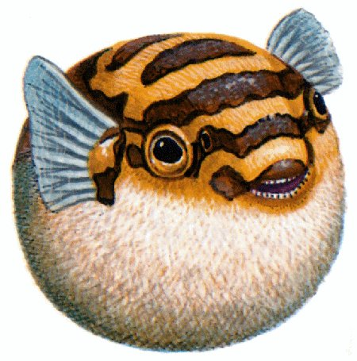
Image from Arthur’s Free Clipart
I’ll start with the first item under Conventions of Standard English for Kindergartners (p. 26) Item 1 is “Demonstrate command of the conventions of standard English grammar and usage when writing or speaking.” It has six lettered sub-sections.
“a. Print many upper- and lowercase letters.” O.K., but how many is “many”? Apparently the writers of the standards don’t believe that kindergartners can learn the entire alphabet, but if that is the case, in a standards document shouldn’t they state which letters?
“b. Use frequently occurring nouns and verbs.” This is pure hot air. Is there any three-year old who does not use “frequently occurring nouns and verbs”?
“c. Form regular plural nouns orally by adding /s/ or /es/ (e.g., dog, dogs; wish, wishes).” Really? How many five-year-olds would say “I saw two dog”?
“d. Understand and use question words (interrogatives) (e.g., who, what, where, when, why, how).” Give me (and parents) a break! Three- and four-year-olds drive parents nuts with these words. My son was three when we were driving down a road and from the back seat he said, “Why are there rocks?” As I pondered an answer, he shot out three more questions.
“e. Use the most frequently occurring prepositions (e.g., to, from, in, out, on, off, for, of, by, with).” What three-year-old does not use these words—and almost always correctly.
“f. Produce and expand complete sentences in shared language activities.” What does this mean? First, are they supposed to produce a sentence, and then repeat it in an expanded form? Second, by the time they get to kindergarten, children have produced thousands of complete sentences. If the objective is poorly stated, and is in fact to have the students produce fewer incomplete sentences, how is that objective to be met, and how will it be tested? Remember, most of us, most of the time, speak in incomplete sentences. You can ask the same questions about many parts of the Core, but there is another source of hot air in the Common Core Pufferfish. Meaningless repetition— repetition is the topic of Part Two of “The Common Core Pufferfish.”

Dr. Vavra has been teaching writing at the college level for almost forty years. He is also the developer of the free KISS Grammar site, a curriculum design and instructional materials that present clear objectives and standards. Additional open letters on the Core are available at KISSGrammar.org/Open_Letters. You may publish or share them in any way you like.
9/1/2014

